Intelligent Seat Allocation

by

Gnaneswar(K18LCA35)

Sirisha(K18LCA36)

Ram(K18LCA04)

Abstract :-

The use of van traveling is a large growing vaniness in India and other countries; the manual use of van

reservation is presently very strenuous and also consumes a lot of time by having to stay on a long queue. For

this reason, an efficient system is to be proposed in this paper to ease the issue of van reservation amongst

indigenes within the country. The system is a web – based application that allows visitors to check van

availability, buy and pay van ticket online. In this paper, the proposed van reservation system was developed

using python programming

The use of van traveling is a large growing vaniness in Nigeria and other countries; the manual use of van reservation is presently very strenuous and also consumes a lot of time by having to stay on a long queue. For this reason, an efficient system is to be proposed in this paper to ease the issue of van reservation amongst indigenes within the country. The system is a web – based application that allows visitors to check van availability, buy and pay van ticket online. In this paper, the proposed van reservation system was developed using python programming.

1. Introduction:

The Online Van Ticket Reservation System is a web-based application that allows visitors check van ticket availability, buy van ticket and pay the van ticket online. There is also a physical limit to the reservation availability as each branch only operates during certain hours and reservations can only be made on-the-spot. These limitations are not the only issues the company is currently facing. Other factors that create problems include human errors. the fluctuation of passengers during certain periods of time that causes a bottleneck in the check-in process because of the inability of the frontofficer to multitask and the lack of overview or report of the on-going vaniness; making it difficult for the company to judge past/current performance or plan future improvements. Looking at these problems and limitations, it is clear that both the company and the customers require an integrated reservation system that is more efficient in information update and reservation handling and also easy to use. Electronic tickets, or e-tickets, give evidence that their holders have permission to enter a place of entertainment, use a means of transportation, or have access to some internet services. Van Ticket Reservation System enables the customer to buy van ticket, make payment, and ask for information online easily. Furthermore, staff can sell van ticket using Van Ticket Reservation System after check van ticket availability for the customer and print the van ticket to the customer that queue up in the counter. The method to solve this problem is to create an online buying van ticket system. Customer can buy the van ticket over the Internet, 24 hours a day, 7 days a week and the van ticket can't be lost, stolen or left behind. In addition, the online system lets the customers check the availability of the van ticket before they buy van ticket Furthermore, customers no need to pay cash to buy van ticket because they can pay the van ticket by using deposit slip number order by bank.

Overview :-

Van Ticket System Van ticket booking during the offline era posed various difficulties to the customers as well as the van operators. Offline ticket booking reduced the scope of customers to choose different options based on their travel criterion It also increased the franchising cost for the van operators. At the same time, the van operators were also finding it difficult to monitor their van seat filling information. Many small and medium van service organizations do not have their own online van ticket booking system. Online Van ticketing system web portal is a total internet ticketing operations offering the benefit of total in-house management of van schedules, ticket bookings, ticket sales, report generation, and other vaniness functions associated with ticket sales .It also offers the power of decision making to customers tomake a ticket booking through van operators’ popularity, performance and ranking. This powerful Internet based ticket booking system that allows a full control of not only on the ticketing inventory, but also the site’s content.

E-Ticket Reservation System E-ticketing could be extended to major entertainment and touristic sites and thus facilitate access to major points of interest within cities, making e-ticketing also interesting for travelers. Urban tourism is the fastest growing tourism sector in the. In public transport, e-ticketing systems are not only means of payment but process huge amount of information which offer a large range of possibilities to make public transport easier to use, to manage and to control. They offer as well opportunities to introduce integrated pricing structure that are not easy to implement with traditional payment tools. Electronic ticketing technologies are classified according to the way they are used for payment. The closer the card is to the payment system, the more reliable the transaction is, but the more constraining it is for the user .Therefore, the long-term objective is for the customer to be able to pay for public transport without having to show or validate any card, relying on fully automatic fare payment.

Methodology :- Description of Proposed System The system is very simple in design and to implement. The system requires very low system resources and the system will work in almost all configurations. It has got following features:

• It will ensure data accuracy.

• Records will be efficiently maintained by DBMS.

• Availability of seats can be enquired easily.

• Passengers can also cancel their tickets easily.

• Minimum time needed for the various processing

. • It will provide better Service. We,stated that system design is to create a technical solution that satisfies the functional requirements for the system. At this point in the project life cycle there should be a Functional Specification, written primarily in vaniness terminology, containing a complete description of the operational needs of the various organizational entities that will use the new system. The challenge is to translate all of this information into Technical Specifications that accurately describe the design of the system, and that can be used as input to System Construction. System Requirement The requirement definition is concerned with the analysis of the existing system with the aim of determining and structuring the requirement of the proposed system. It is achieved with the aid of user requirement. The Analysis stage was specifically carried out in focus of the functionality dataflow at Young Legacy Line Transport Division. Requirement Specification Requirement Specification a complete description of the behavior of a system to be developed and may include a set of use cases that describe interactions the users will have with the software. In addition it also contains nonfunctional requirements. Non-functional requirements impose constraints on the design or implementation Functional Requirements Functional requirements define the specific functions that the system performs, along with the data operated on by the functions. The functional requirements are presented in scenarios that depict an operational system from the perspective of its end users. Included are one or more examples of all system features and an enumeration of all the specific requirements associated with these features

RESULTS AND DISCUSSIONS:-

The proposed van reservation system was developed using python programming. As to determine the ages accordingly we have allotted the seats and also for physically chalanged persons there was a special seat for their convenience

Code:-

name= input("enter your name:")

print("hello",name)

num= int (input("enter your age:"))

if num<26:

print(name,"your at last")

elif num<=51:

print(name,"you are at middle")

elif num >=50:

print( name,"your are at front")

opp={1:18,2:17,3:16,4:15,5:14,6:13,7:12,8:11,9:10,10:9,11:8,12:7,13:6,14:5,15:4,16:3,17:2,0:1}

T=int(input("what is the no of the person: "))

for i in range(T):

n=int(input("which seat do you want: "))

compartment=(n-1)//18

position=n%18

oppseat=opp[position]

seat=(compartment*18)+oppseat

print(seat, end=" ")

if position in [0,1,3,5,7,9,12,14,16]:

print("WS")

if position in [2,4,6,8,10,11,13,15,17]:

print("AS")

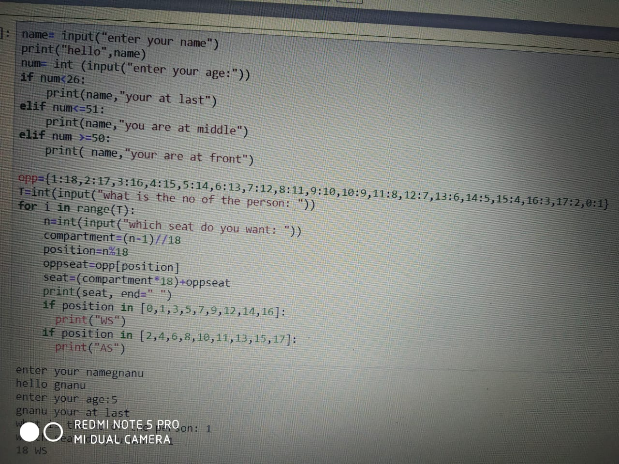

CONCLUSION:- Nowadays, van agencies are taking important role in transportation, and to make reservation reliable they need a strong system that they will make reservation easier, faster and safer. This project designed to meet requirements of a van reservation system. It has been developed in XHTML, PHP, CSS, JAVASCRIPT and database has been built in MySQL. By using this application, the company can provide reservation services and information to their customers without the limitation of office hours or manpower. Not only does it let customers book trips around the clock from any location with an internet connection but it is also designed for use by the company to internally manage their vaniness processes; minimizing human errors and overcoming difficulties and problems that arose in the previous system.

REFRENCES:-

1. Asad, A.A., Ayad, M.J. and Hayder, N.K. (2012). Design and Developing Online Iraqi Van Reservation System Using Unified Modeling Language. International Journal of Scientific knowledge Available at: http://www.ijsk.org/uploads/3/1/1/7/3117743/v3i103_information_technology.pdf Accessed 13th December 2014 2. Gayathry, S. (2013). Online Van Ticketing System: Tactful Management Research Journal Through Case Studies.RedVan.in

Github link: <https://github.com/Gnaneswar510/gnaneswar/tree/master>